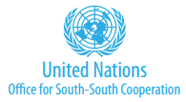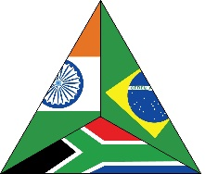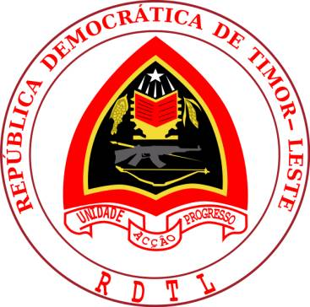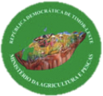

PROJECT TITLE: | Conservation Agriculture, Permaculture and Sustainable Fisheries Management: Enhancing Food and Nutrition Security and Reducing Disaster Risk in Timor-Leste
PROJECT SYMBOL: | GCP/TIM/007/IBS
Cooperating Country: | Timor-Leste
South-South Resource Partner: | India, Brazil and South Africa Fund
Government Counterpart: | Ministry of Agriculture and Fisheries
Expected Start/End Dates: | July 2015 / June 2018
Contribution to FAO’s Strategic Framework:
- National Action Plan for a Hunger and Malnutrition-Free Timor-Leste Pillars: | 3. All food systems are sustainable  4. 100 percent increase in smallholder productivity and income
- Country Programming Framework Outcomes: | 2.1. Increased availability, access to and utilisation of a wider range of food variety  3.1. Improved livelihoods, living conditions and welfare of smallholder fisherfolk
- Strategic Objective: | 5. Increase the resilience of livelihoods to threats and crises
- Regional Priority Areas: | E. Coping with the impact of climate change on food and agriculture
Environmental Impact Assessment Category: B
FAO Budget (inclusive of 7% indirect support costs): | USD 1,387,157.28
UNOSSC (3 % support costs): | USD 41,614.72
Total IBSA Fund Contribution: | USD 1,428,772
Agreed by The Government of Timor-Leste:
Name:
Date:
The Food and Agriculture Organization The United Nations Office for South-South
of the United Nations: (as Implementing Cooperation (as IBSA Fund Manager/ Agency): Secretariat):
Name: Name:
Date: Date:

